|  |  |
| --- | --- |
| Course Name | ITD 2313 – Script Programming |
| Instructor | Michael Schnell |
| Student Name | Charles Morris |
| Due date | 6/11/2023 |
| Grade | Put grade earned here |
| Grading Comments | Put instructor comments here |

Textbook Exercise Week 6

**Accessing Characters and Substrings in Strings**

**The Structure of Strings**

**Page 103**

1. The first code example block which is about 1/2 way down the page is a simple review of some previous material dealing with strings.
2. The 2nd code example block on the page near the bottom starts looking into what we can do with strings.

**The Subscript Operator**

**Page 104**

1. The first code example block on this page is a series of commands.  There is even one that has an error in it.  Do not correct that error.  You need to see and capture that error in the screen shot.
2. The second code example block begins at the bottom and does spill over onto the top of the next page.  The portion that spills over is the output so go ahead and put this screen shot with the page 104 grouping.

**Slicing for substrings**

**Page 105**

1. Slicing is an important concept when using strings in Python.  Be sure to do all of the code example block in the middle of the page.

**Testing for a Substring with the *in* operator**

**Page 106**

1. There is a small code block example at the top of the page to demonstrate how the operator works

**Data Encryption**

**Page 108**

1. There are two rather large code example blocks here.  One to Encode and one to Decode.  The good news is that you do not have to type them in.  They are included in the data files for this chapter.  Run the programs multiple times using 3 at least one set of code and decode to show the versatility of the two programs.

**Strings and Number Systems**

**Converting Binary to Decimal**

**Page 111**

1. The code example block for this one is also available in your download for this chapter.  Run it and show the same inputs as the text and then run them again with different inputs to see what you get.

**Converting Decimal to Binary**

**Page 112**

1. The code example block for this one is also available in your download for this chapter.  Run it and show the same inputs as the text and then run them again with different inputs to see what you get.

**String Methods**

**Page 115**

1. 3/4 the way down the page you will find the code example block for this page.

**Page 117**

1. The first code example block on this page is rather long so it might take multiple screen shots to get this one and the next one on the page.

1. The second code example block on the page is at the bottom.  It does not roll over so it is included on this page.  Again it might take multiple screen shots to get all the code example blocks on this page.

**Text Files**

**Writing Text to a File**

**Page 119**

1. This is an unusual one.  In this small section, there are several code lines but there is no output.  That is because the output is in a file.  So for this one, you will run the code lines start to finish and then grab the screen shot of all of them.  Then to show they worked, find the file it created on your hard drive and open it.  Then grab a screen shot of that file open in whatever text editor you use.
2. Do not delete the file when you are done, you will use it later.

**Writing Number to a File**

**Page 120**

1. This is another unusual one.  In this small section, there are several code lines but there is no output.  That is because the output is in a file.  So for this one, you will run the code lines start to finish and then grab the screen shot of all of them.  Then to show they worked, find the file it created on your hard drive and open it.  Then grab a screen shot of that file open in whatever text editor you use.
2. Do not delete this file either.  You will use it later also.

**Reading Text from a file**

**Page 120**

1. Normally for a single page we would do all the code blocks together but the file handling is a bit special.  It uses a file you created earlier so make sure the file name is correct.  Nothing may show when you execute the first code example block in this subsection of the text.  Still screen shot that you did it.
2. Executing the code example block just after the half way mark on the page will have output you can capture with your screen shot.
3. There will be output for the last code example block on this page to grab into the screen shot.

**Page 121**

1. The code block at the top of this page finishes off the Reading Text subsection.

**Reading Numbers from a File**

**Page 121**

1. This code block will be towards the bottom of your page.  It utilizes one of the files created earlier.  Make sure you have the correct file name.

**Page 122**

1. The code example block here uses that file again.  Check that file name to be sure.  There is output to capture for the screen shot.

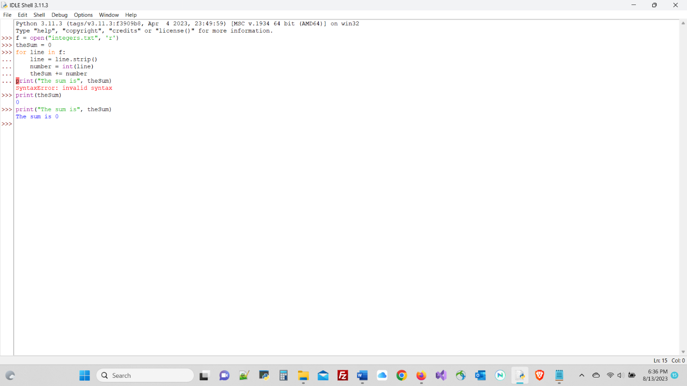

**Accessing and Manipulating files and Directories on Disk**

**Page 123**

1. You can if you want do the code example blocks on this page.  Do not though include any screen shots into the submission document for this page.

**Page 124**

1. This page does have a code example block you are to execute and run and grab that screen shot for the submission document.

There is a case analysis at the end of the chapter. You will not have to put any screen shots in from that case analysis.  You should though read through and try some of the topics in there for your benefit and experience.

